24 October 2022
New displays open at Oxford University Museum of Natural History in second phase of Life, as we know it masterplan
Oxford University Museum of Natural History announces the opening of the first major changes to its permanent displays in over 20 years. Involving the movement and conservation of thousands of specimens over the past two years, the project has transformed the Museum’s stunning centre court.
From a gigantic Japanese Spider Crab to meteorites as old as the solar system, the specimens in the new exhibits reveal our understanding of Biodiversity, Evolution, and the history of the Earth. The displays complete the second phase of the Life, as we know it masterplan which began in 2018 and will continue with a further 16 new exhibits opening in spring 2024. This project will transform the Museum for visitors over the coming years, with fresh, bold design sitting alongside the unique Victorian architecture.
Ten new displays in the centre court celebrate biodiversity – the variety of life on Earth. These visually striking exhibits introduce visitors to some of the many forms of diversity in nature, including colour, shape, and size. A selection of some of the weird and wonderful creatures that make up the animal kingdom are on display in Animal diversity, while Great and small presents the huge range of scale found in the planet’s largest group of animals – the arthropods – that includes insects, spiders, crabs and lobsters.
The story of the emergence of life starts in the deep vents of the ocean in the Life and water display, and its diversification from a common ancestor is visualised in a tree of life created by the Museum team especially for the new displays. Specimens of modern whales and their ancestors illustrate evolution in action, showing how mammal limbs, teeth and even nostrils evolved over time to suit an aquatic life.
Human impact on the environment is addressed in the Museum’s permanent exhibits for the first time. Sculptural hands in the Future in our hands display evoke the responsibility that we carry in protecting biodiversity. Each hand was cast in the Museum from people who currently work, or have an interest in, the conservation of nature. From a six-year-old girl who lives on an organic farm in Oxfordshire to a former head of BirdLife Africa, the participants’ hands cradle species that are either now under threat or have sadly already become extinct, such as the Thylacine and the famous Dodo.
Professor Paul Smith, director of the Museum of Natural History, said:
“With their striking, contemporary designs and a focus on core scientific ideas, these displays are a big step forward for the Museum. In them, we are taking a broader look at the complex interactions between life and the environment, both today and across geological time. And we are also offering an opportunity for visitors to reflect on our impact on the biodiversity of the future.”
The last major redevelopment of the permanent exhibits was in the early 2000s, when 175,000 people visited the Museum each year. Today, it receives more than 750,000 visitors annually, welcoming people of all ages and interests, and from all parts of the world.
The Life, as we know it project is generously supported by funding from FCC Communities Foundation. The next phase of redevelopment, beginning in 2023, will transform the north gallery with new exhibits on Present-day ecosystems, as well as completing the Evolution and Biodiversity aisles.
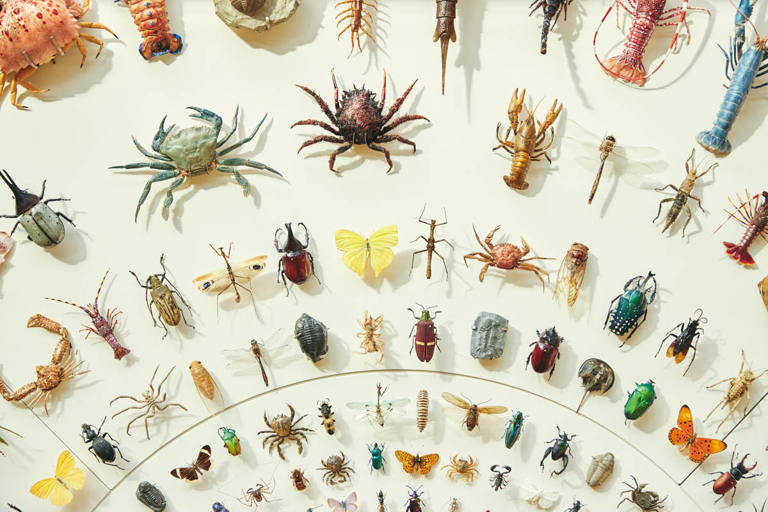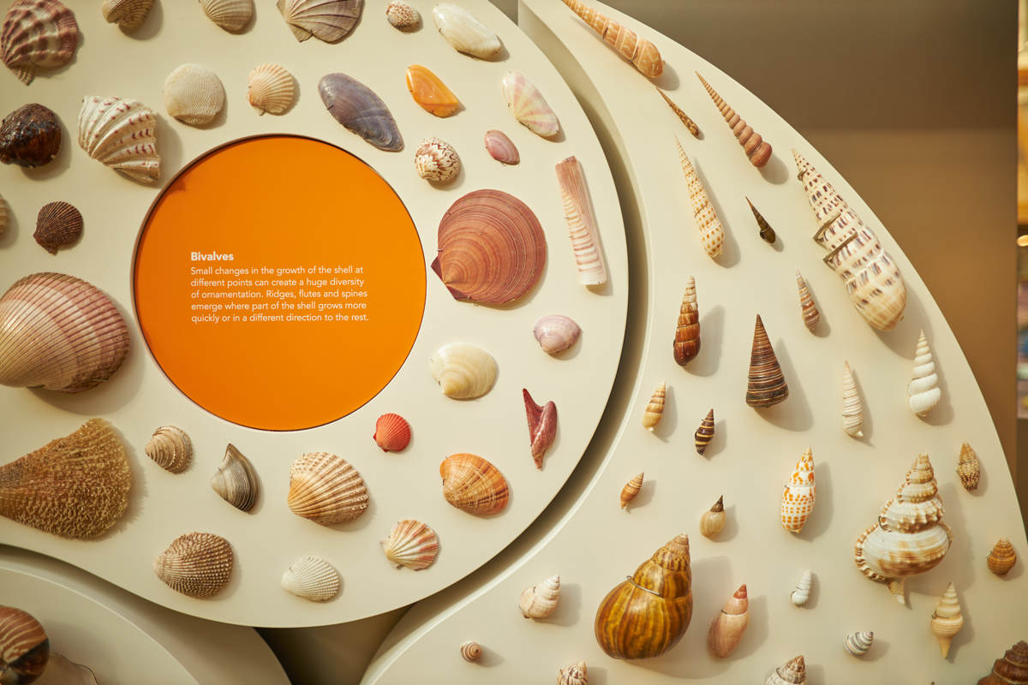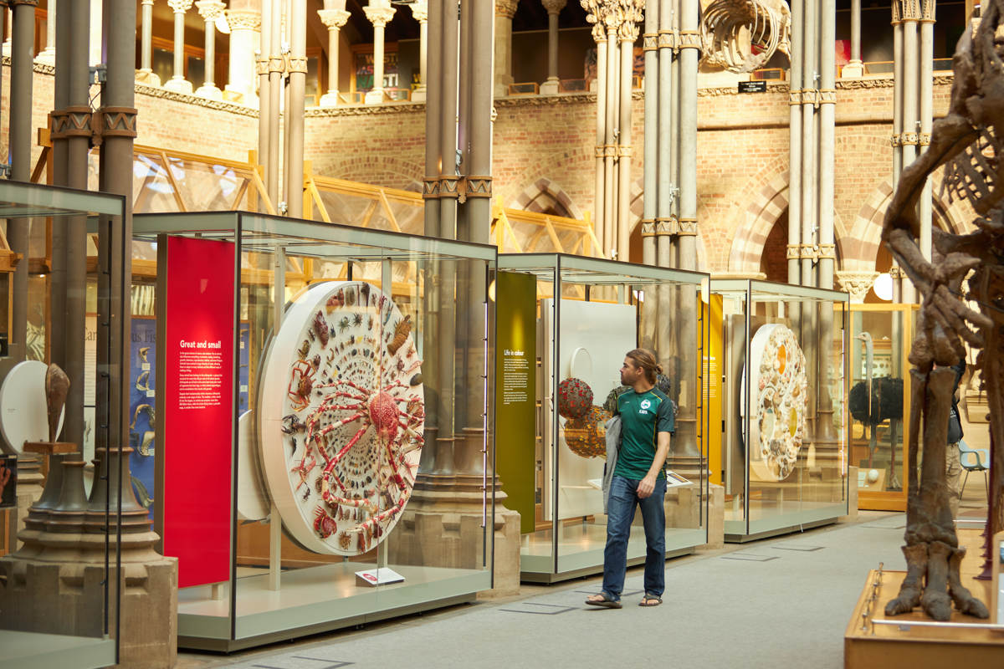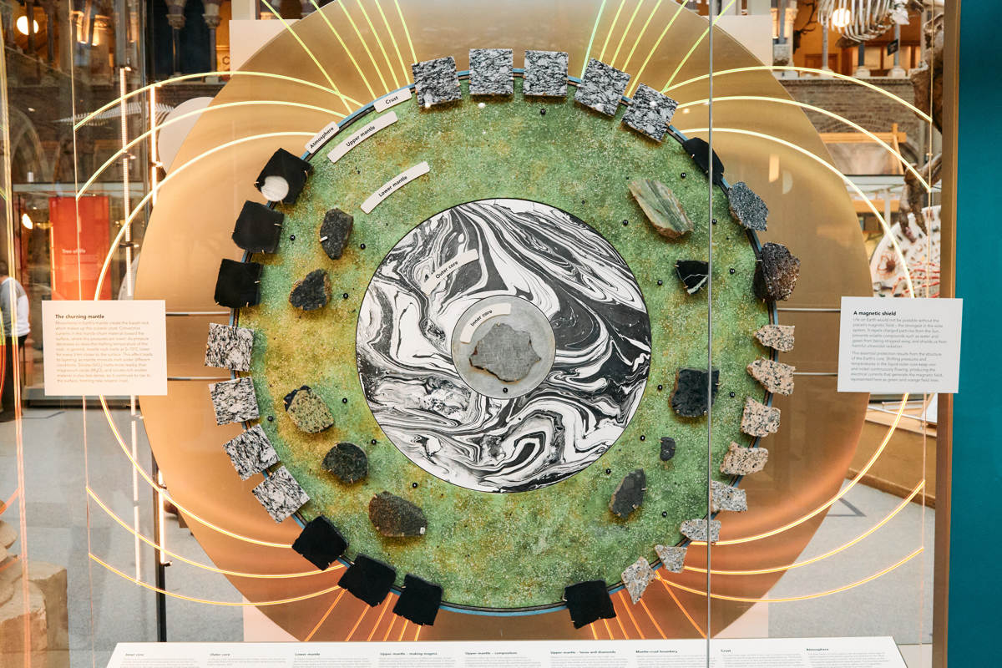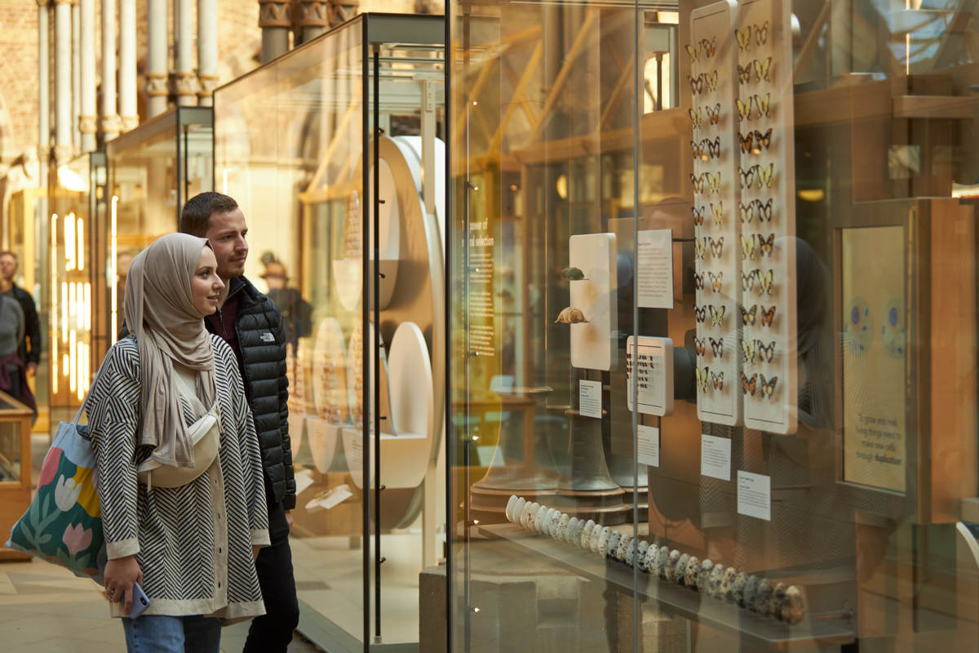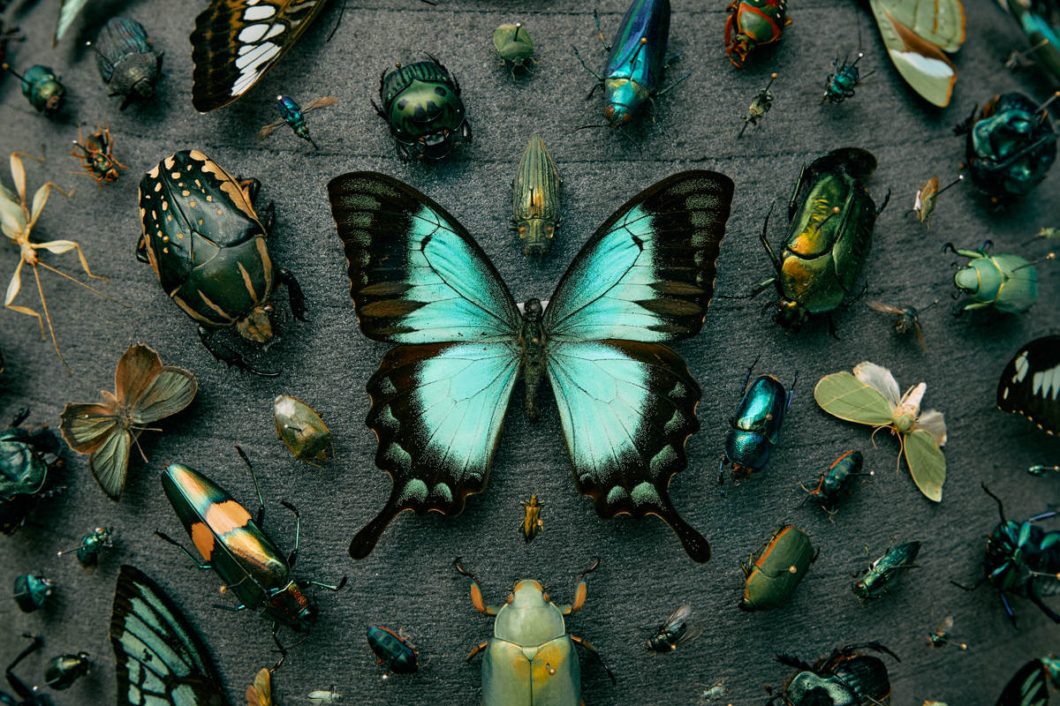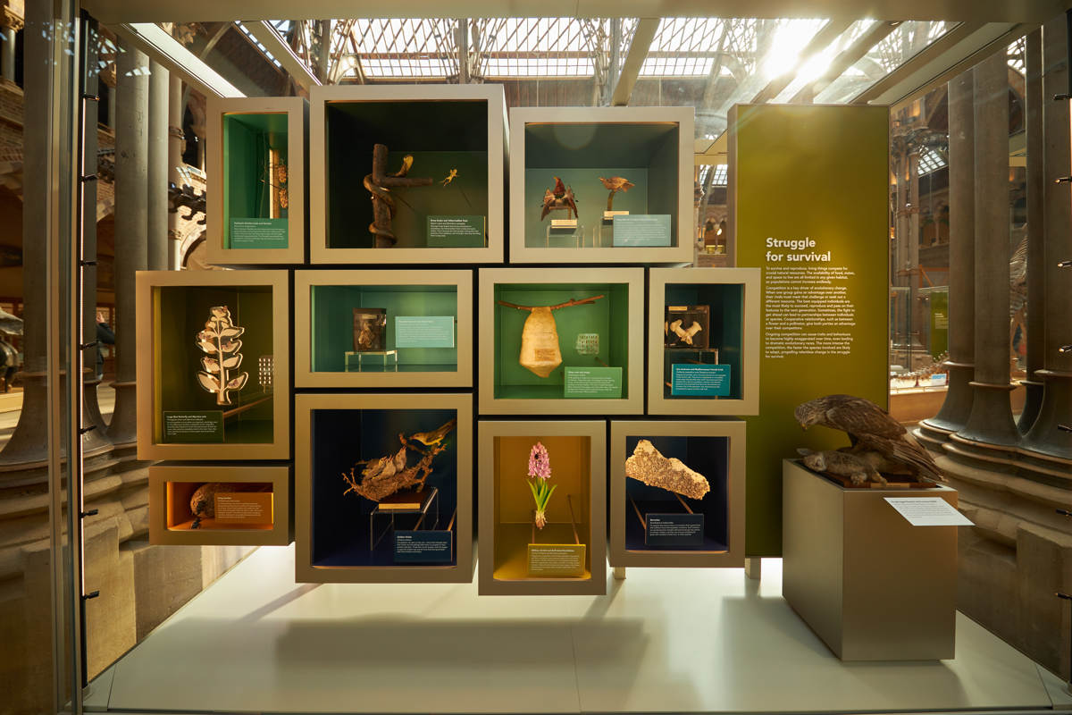
High resolution images are available for use by members of the media here.
For further information:
Scott Billings
Life, As We Know It project manager
Museum of Natual History
scott.billings@oum.ox.ac.uk
01865 270925

Notes to editors
About Oxford University Museum of Natural History

Founded in 1860 as the centre for scientific study at the University of Oxford, the Museum of Natural History now holds the University’s internationally significant collections of entomological, geological and zoological specimens. Housed in a stunning Pre-Raphaelite-inspired example of neo-Gothic architecture, the Museum is free to enter, and its growing collections underpin a broad programme of natural environment research, teaching and public engagement.

The Museum won Museum + Heritage’s Partnership of the Year award in 2022, and the Best of the Best award in 2016. In 2015, it was a Finalist in the Art Fund Prize for Museum of the Year.
www.oumnh.ox.ac.uk
www.morethanadodo.com
About FCC Environment
FCC Environment is the leading UK waste and resource management company and is part of a global group with a strong heritage in providing services for communities and business. Its vision is to be the environmental company of choice, delivering change for a sustainable future. It employs 2,400 people and operates more than 200 facilities across England, Scotland and Wales. FCC Environment donates the landfill tax credits that are generated by its operations to FCC Communities Foundation, in order to add value to the environmental and social infrastructure of the communities around landfill sites.
www.fccenvironment.co.uk

About FCC Communities Foundation
FCC Communities Foundation is a not-for-profit business that awards grants for community, conservation and heritage projects from funds donated by FCC Environment through the Landfill Communities Fund and Scottish Landfill Communities Fund. Since 1998, FCC Communities Foundation has granted over £200m to more than 7,000 projects which benefit people living within 10 miles of a FCC Environment landfill site. For more information please visit www.fcccommunitiesfoundation.org.uk.

About Landfill Communities Fund / Scottish Landfill Communities Fund
The Landfill Communities Fund and Scottish Landfill Communities Fund - any waste that is discarded which cannot be reused, reprocessed or recycled may ultimately be disposed of in a landfill site. To encourage the re-use, recycle and recovery of more value from waste and use more environmentally friendly methods of waste disposal, Landfill Tax is charged on each tonne of waste sent to landfill. Landfill Operators (LOs) are able to redirect a small proportion of landfill tax liability to support a wide range of community and environmental projects in the vicinity of landfill sites through the Landfill Communities Fund (LCF) and Scottish Landfill Communities Fund (SLCF). The LCF is regulated by ENTRUST on behalf of HM Revenue & Customs, and the projects are delivered by enrolled Environmental bodies (EBs). The SLCF is regulated by SEPA on behalf of R evenue Scotland and projects are delivered by Approved Bodies (ABs).

