APPLICATION FORM  Museum of Natural History Visiting Fellowships 2019-20  To be submitted with the statement of proposed research  Application deadline for the Fellowships: 30 April 2019  For office use:  Register no: | 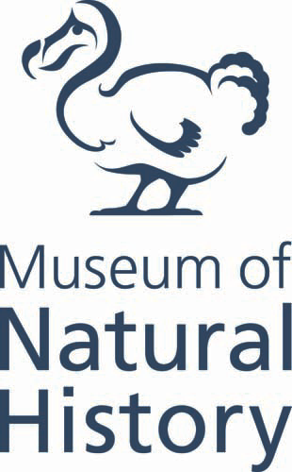
PERSONAL DETAILS
Title |  | Full name
Home address
Email address
Telephone (or mobile)
Home institution/ affiliation/organisation (include full address) |  |  |  | Job title

DETAILS OF PROPOSED RESEARCH
Project title
Proposed start date |  | Proposed end date
Museum Collections to be consulted during the Fellowship | Please be as specific as possible

REFEREE DETAILS (including email addresses)
Referee #1

Referee #2

HOW DID YOU LEARN OF THE MUSEUM VISITING FELLOWSHIPS?
Please √ as appropriate | Museum website Social media From a member of staff  From a friend/colleague Other (please specify): ____________________________

Please return this completed form to fellowships@oum.ox.ac.uk along with:

Your up-to-date curriculum vitae;
2 letters of recommendation: Your referees may email us directly; and
A statement of the proposed research (1000 words maximum): This should specify how
the Museum’s Collections will support the research topic and the contribution
that this visit will make to your own research goals.

Note: Each document must be sent as an individual pdf file. Please do not combine all the documents into one pdf file.

Emailed applications and letters of recommendation MUST bear the subject line: Visiting Fellowships Application - Name

