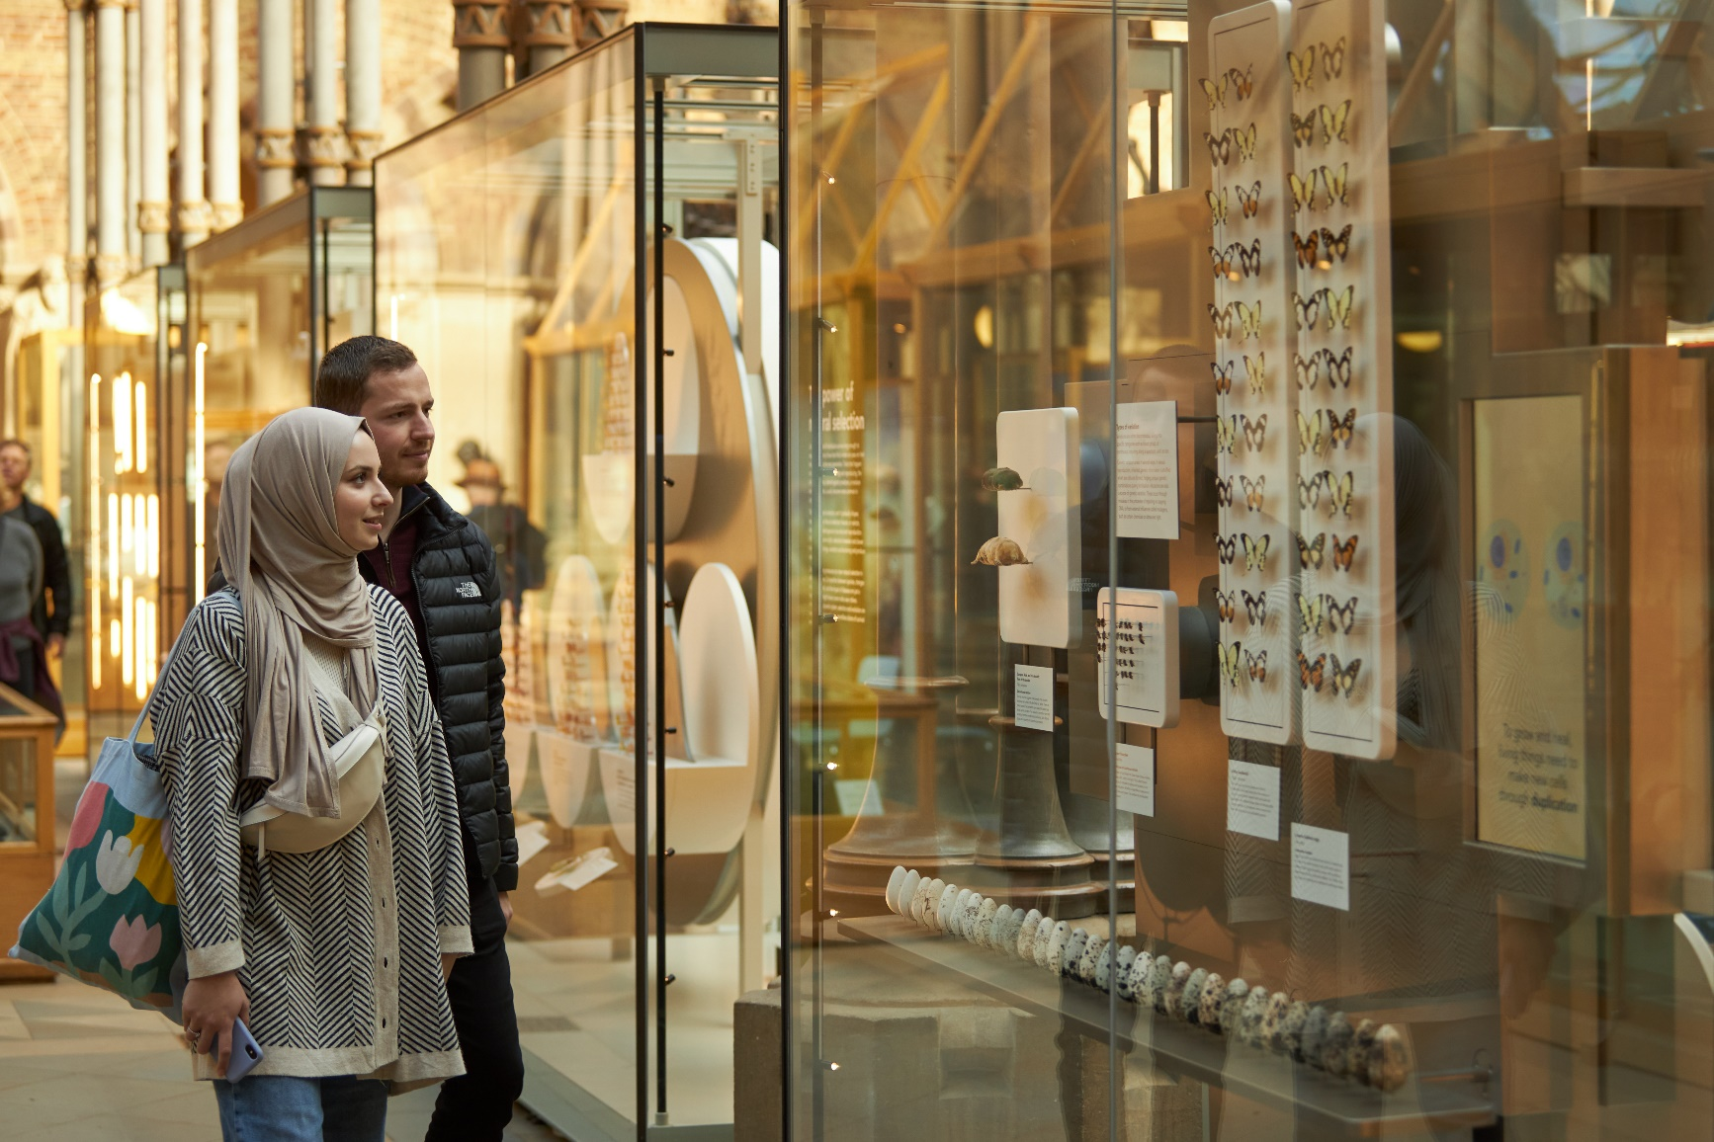

Job Description

Job title | Visitor Services Assistant
Division | Gardens, Libraries and Museums (GLAM)
Department | Museum of Natural History
Grade and salary | Grade 2: £22,150 per annum pro-rata
Hours | Part-time, 2 roles available:  4 days per week (0.8 FTE)  3 days per week (0.6 FTE)
Contract type | Fixed-term, July – 10th September
Reporting to | Visitor Services Manager
Vacancy reference

The role

The Visitor Services team is the welcoming face of the Museum of Natural History and an integral part of the visitor experience and the Museum’s Visitor Giving Project. The Visitor Services Assistants (VSAs) work together to ensure a high level of customer care in their welcome and wider communication with Museum’s 800,000 annual visitors, providing information and requesting donations which support the Museum’s activities.
The post-holder must have experience of working in visitor services, either at a museum, gallery or heritage site, at a reception, or in another customer-focussed environment. The VSA position requires excellent interpersonal skills, a professional attitude and a flexible approach to the role. The Museum is a vibrant and busy working environment and the Front of House team is required to be approachable and adaptable.
In addition to the fixed hours set out on the first page of the job description, the post-holder must be willing to cover occasional evening events. If working weekends, the post-holder will be required to stay on site over lunch to assist with emergency procedures if needed (this is regarded as paid-time).

Responsibilities

Reception and welcome
- Acts as a first point of contact for all visitors to the Museum, providing an excellent welcome and ensuring a high standard of customer service
- Helps support the Museum by encouraging donations and the sale of visitor guides and other products
- Provides a helpful, informative and efficient service to all visitors and staff while resolving any issues in a calm and diplomatic manner
- Liaises with education staff and volunteers and act as the first point of contact for weekend volunteers
- Refers external enquiries to the relevant section of the Museum, including phone enquiries
- Works in partnership with neighbouring departments, including the Pitt Rivers Museum
- Ensures the Museum is always presented at its best, including keeping areas clean and tidy, identifying and dealing with trip and slip hazards and ensuring visitor guides and leaflets are kept well-stocked.

Security and safety
- Interprets and enforce the Museum’s policies in a sensible and sensitive but firm manner and uses judgement on challenging individuals or groups under the Museum’s policies
- The post-holder is expected to be a nominated first-aider, first-aid training will be provided
- Play a role in evacuating visitors safely from the Museum should an emergency arise
- Is responsible for opening and closing the building at the start and end of each day
- Remains aware of all people entering the Museum (visitors, Museum staff, University staff and students, contractors)
- Carries out regular patrols of the building
- Liaises with the University’s central security team, including on car parking matters.

Other
- Undertakes event duties required by conference and reception organisers under the direction of the Events Manager
- Moves furniture and sets up rooms/areas, sets up AV equipment when necessary
- Observes and reports faults and defects in the fabric, services and decoration of the building to the Building Manager
- Records and processes object identification enquiries
- Records visitor numbers from the electronic visitor counter
- Occasional cash counting duties.

Selection criteria

Essential selection criteria

Excellent customer service and interpersonal skills and ability to communicate with a wide range of people

The ability to remain calm under pressure and use sound judgement to make decisions in a busy environment

A confident and proactive manner to asking for visitor donations and making conversions to Gift Aid when appropriate

Experience of working in a busy visitor attraction, heritage site or retail environment

Experience of working successfully in a team and with a wide range of people

Reliability and good time-keeping skills

Experience/understanding of health and safety, security and housekeeping issues

IT skills

Ability to lift and move furniture, signs and AV equipment

Desirable selection criteria
- Responsibility for dealing with building security in a previous role
- An interest in the Museum of Natural History and its Collections
- Second language skills

Pre-employment screening

Standard checks
If you are offered the post, the offer will be subject to standard pre-employment checks. You will be asked to provide: proof of your right-to-work in the UK; proof of your identity; and (if we haven’t done so already) we will contact the referees you have nominated. You will also be asked to complete a health declaration so that you can tell us about any health conditions or disabilities for which you may need us to make appropriate adjustments.
Please read the candidate notes on the University’s pre-employment screening procedures at: https://www.jobs.ox.ac.uk/pre-employment-checks

Hazard-specific / Safety-critical duties
This job includes hazards or safety-critical activities. If you are offered the post, you will be asked to complete a health questionnaire which will be assessed by our Occupational Health Service, and the offer of employment will be subject a successful outcome of this assessment.
The hazards or safety-critical duties involved are as follows:
- Regular manual handling

Additional security pre-employment checks
This job includes duties that will require additional security pre-employment checks:
- A satisfactory basic Disclosure and Barring Service check due to access to Museum collections

About the University of Oxford

Welcome to the University of Oxford. We aim to lead the world in research and education for the benefit of society both in the UK and globally. Oxford’s researchers engage with academic, commercial and cultural partners across the world to stimulate high-quality research and enable innovation through a broad range of social, policy and economic impacts.
We believe our strengths lie both in empowering individuals and teams to address fundamental questions of global significance, while providing all our staff with a welcoming and inclusive workplace that enables everyone to develop and do their best work. Recognising that diversity is our strength, vital for innovation and creativity, we aspire to build a truly diverse community which values and respects every individual’s unique contribution.
While we have long traditions of scholarship, we are also forward-looking, creative and cutting-edge. Oxford is one of Europe's most entrepreneurial universities and we rank first in the UK for university spin-outs, and in recent years we have spun out 15-20 new companies every year. We are also recognised as leaders in support for social enterprise.
Join us and you will find a unique, democratic and international community, a great range of staff benefits and access to a vibrant array of cultural activities in the beautiful city of Oxford.
For more information, please visit www.ox.ac.uk/about/organisation.

Oxford University Museum of Natural History

Oxford University Museum of Natural History was opened in 1860 and houses the University’s extensive scientific holdings of natural history, which are used for research, teaching, and public engagement with science. The holdings are currently organised into three collection areas: Earth, Life, and the library and archives. The Museum is ‘Designated’ by Arts Council England as having collections of national and international importance, and these comprise around 7 million specimens that are second in importance only to the national collections. The building, which is Grade 1-listed, is regarded as one of the finest examples of Victorian architecture in Britain, with its glass roof supported by iron columns, and internal decoration that has a strong association with the Pre-Raphaelite art movement.
The Museum is one of the most visited science museums in the UK with over 800,000 visitors per year, including over 40,000 school visitors, making it the most popular non-national science museum in the UK and the second most visited university museum globally (behind Oxford’s Ashmolean Museum).
The Museum places equity in science at the core of its ethos and is an Athena SWAN Silver Award holder.
For more information about the museum, please visit: www.oumnh.ox.ac.uk.

Gardens, Libraries and Museums (GLAM) Division

The Gardens, Libraries and Museums (GLAM), a group of six departments led by the Pro-Vice-Chancellor (GLAM), comprises the University’s major collections: the Bodleian Libraries, the four museums – Ashmolean, History of Science, Natural History, and Pitt Rivers – and the Botanic Garden & Harcourt Arboretum. Both individually and collectively, the collections are integral to the delivery of the University’s strategic aims of teaching, research and widening participation. Whilst each collection maintains a distinct individual identity, GLAM also works collectively where practicable to ensure sustainability and consistency of standards.
For more information please visit: http://www.admin.ox.ac.uk/glam/

How to apply
Applications are made through our online recruitment portal. Information about how to apply is available on our Jobs website https://www.jobs.ox.ac.uk/how-to-apply.
Your application will be judged solely on the basis of how you demonstrate that you meet the selection criteria stated in the job description.
As part of your application you will be asked to provide details of two referees and indicate whether we can contact them now.
You will be asked to upload a CV and a supporting statement. The supporting statement must explain how you meet each of the selection criteria for the post using examples of your skills and experience. This may include experience gained in employment, education, or during career breaks (such as time out to care for dependants)
Please upload all documents as PDF files with your name and the document type in the filename.
All applications must be received by midday UK time on the closing date stated in the online advertisement.

Information for priority candidates
A priority candidate is a University employee who is seeking redeployment because they have been advised that they are at risk of redundancy, or on grounds of ill-health/disability. Priority candidates are issued with a redeployment letter by their employing department(s).
If you are a priority candidate, please ensure that you attach your redeployment letter to your application (or email it to the contact address on the advert if the application form used for the vacancy does not allow attachments).

If you need help
Application FAQs, including technical troubleshooting advice is available at: https://staff.web.ox.ac.uk/recruitment-support-faqs
Non-technical questions about this job should be addressed to Ellie Talbot, Visitor Services Manager – ellie.talbot@oum.ox.ac.uk / 01865 272966.
To return to the online application at any stage, please go to: www.recruit.ox.ac.uk.
Please note that you will receive an automated email from our online recruitment portal to confirm receipt of your application. Please check your spam/junk mail if you do not receive this email.

Important information for candidates

Data Privacy
Please note that any personal data submitted to the University as part of the job application process will be processed in accordance with the GDPR and related UK data protection legislation. For further information, please see the University’s Privacy Notice for Job Applicants at: https://compliance.admin.ox.ac.uk/job-applicant-privacy-policy. The University’s Policy on Data Protection is available at: https://compliance.admin.ox.ac.uk/data-protection-policy.

The University’s policy on retirement
The University operates an Employer Justified Retirement Age (EJRA) for very senior research posts at grade RSIV/D35 and clinical equivalents E62 and E82, which with effect from 1 October 2023 will be 30 September before the 70th birthday. The justification for this is explained at: https://hr.admin.ox.ac.uk/the-ejra.
For existing employees on these grades, any employment beyond the retirement age is subject to approval through the procedures: https://hr.admin.ox.ac.uk/the-ejra.
There is no normal or fixed age at which staff in posts at other grades have to retire. Staff at these grades may elect to retire in accordance with the rules of the applicable pension scheme, as may be amended from time to time.

Equality of opportunity
Entry into employment with the University and progression within employment will be determined only by personal merit and the application of criteria which are related to the duties of each particular post and the relevant salary structure. In all cases, ability to perform the job will be the primary consideration. No applicant or member of staff shall be discriminated against because of age, disability, gender reassignment, marriage or civil partnership, pregnancy or maternity, race, religion or belief, sex, or sexual orientation.

Benefits of working at the University

Employee benefits
University employees enjoy 38 days’ paid holiday, generous pension schemes, travel discounts, and a variety of professional development opportunities. Our range of other employee benefits and discounts also includes free entry to the Botanic Gardens and University colleges, and discounts at University museums. See https://hr.admin.ox.ac.uk/staff-benefits

University Club and sports facilities
Membership of the University Club is free for all University staff. The University Club offers social, sporting, and hospitality facilities. Staff can also use the University Sports Centre on Iffley Road at discounted rates, including a fitness centre, powerlifting room, and swimming pool. See www.club.ox.ac.uk and https://www.sport.ox.ac.uk/.

Information for staff new to Oxford
If you are relocating to Oxfordshire from overseas or elsewhere in the UK, the University's Welcome Service website includes practical information about settling in the area, including advice on relocation, accommodation, and local schools. See https://welcome.ox.ac.uk/
There is also a visa loan scheme to cover the costs of UK visa applications for staff and their dependents. See https://staffimmigration.admin.ox.ac.uk/visa-loan-scheme

Family-friendly benefits
With one of the most generous family leave schemes in the Higher Education sector, and a range of flexible working options, Oxford aims to be a family-friendly employer. We also subscribe to the Work+Family Space, a service that provides practical advice and support for employees who have caring responsibilities. The service offers a free telephone advice line, and the ability to book emergency back-up care for children, adult dependents and elderly relatives. See https://hr.admin.ox.ac.uk/my-family-care Childcare
The University has excellent childcare services, including five University nurseries as well as University-supported places at many other private nurseries.
For full details, including how to apply and the costs, see https://childcare.admin.ox.ac.uk/

Disabled staff
We are committed to supporting members of staff with disabilities or long-term health conditions. For further details, including information about how to make contact, in confidence, with the University’s Staff Disability Advisor, see https://edu.admin.ox.ac.uk/disability-support

Staff networks
The University has a number of staff networks including the Oxford Research Staff Society, BME staff network, LGBT+ staff network and a disabled staff network. You can find more information at https://edu.admin.ox.ac.uk/networks

The University of Oxford Newcomers' Club
The University of Oxford Newcomers' Club is an organisation run by volunteers that aims to assist the partners of new staff settle into Oxford, and provides them with an opportunity to meet people and make connections in the local area. See www.newcomers.ox.ac.uk.

