2 July 2024
New permanent exhibits at Oxford University Museum of Natural History reveal Life, as we know it
Sixteen beautiful new displays open at Oxford University Museum of Natural History this summer, in the latest phase of a major overhaul of its centre court. The Life, as we know it project offers visitors an aesthetic take on some of the most important ideas about how the natural world works, showcasing hundreds of specimens, bespoke taxidermy and models, and exquisite glass sculptures.
The latest displays complete three new thematic zones in the court: Biodiversity, Evolution, and Ecosystems. A series of stylised dioramas present ecosystems from six different environments, each looking at a critical process in the interactions between organisms and environment. New ethically sourced taxidermy includes a mother and infant Hamadryas Baboon, a sleeping Koala, and a cheeky-looking raccoon.
Since its foundation in 1860, the Museum has blended art and science in its exploration of nature. This philosophy is honoured with the inclusion of four delicate glass artworks – three by UK artist Luke Jerram and one commissioned specially from glass artist Pratibha Mistry. Three of these sculptures feature in a display on the surprising influence of viruses on the development of life, including their role in the evolution of the mammalian placenta.
Embedded digital interpretations support the natural history specimens, allowing visitors to dig a little deeper into the ideas being explored. In one display, animated 3D models are shown alongside skeletal material to reveal correspondences between the forelimb bones of a wide range of mammals, reptiles, and birds, all of which share an evolutionary origin.
“Since the Life, as we know it project began, the Museum’s visitor numbers are running at 10 per cent above the highest levels recorded in its 160-year history,” said Museum director, Professor Paul Smith. “With further promotion through a city centre bus route campaign we hope even more new visitors will become excited about the natural world through these beautiful new displays.”
Phase 3 of Life, as we know it has been generously supported by funding from FCC Communities Foundation and the DCMS/Wolfson Museums and Galleries Improvement Fund. Funding is currently being sought for the fourth and final phase of the renewal of the main court displays.
The Museum of Natural History is open daily from 10am – 5pm and admission is free.
*
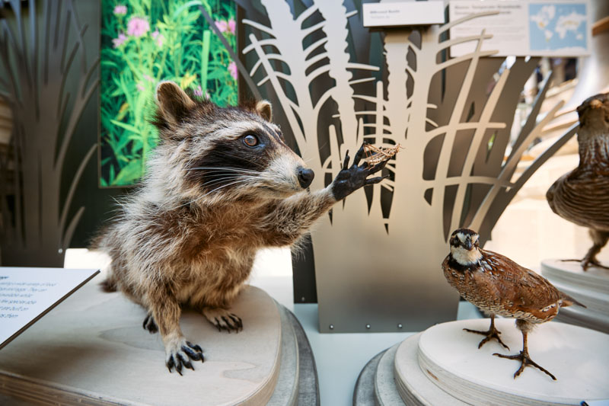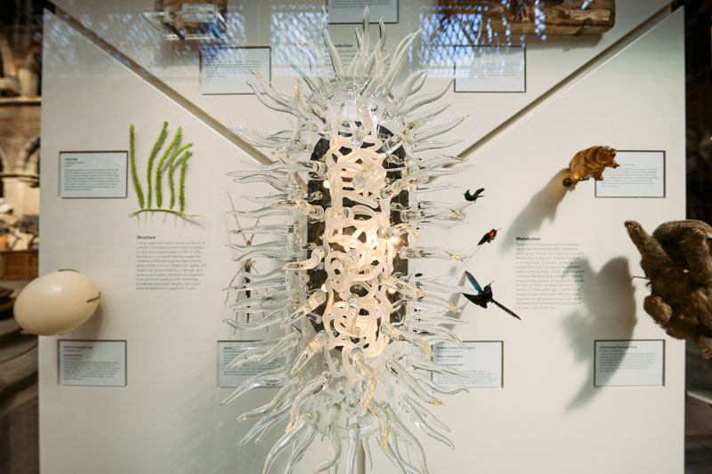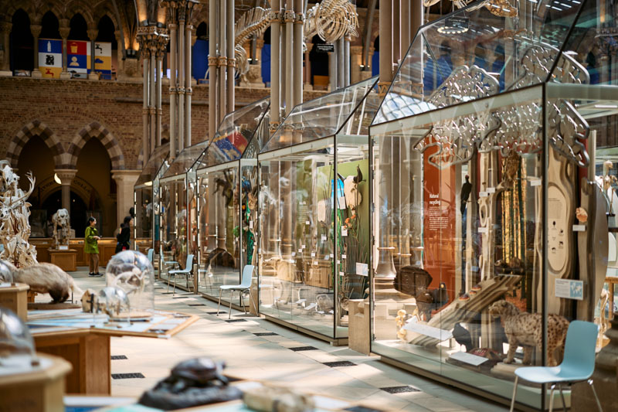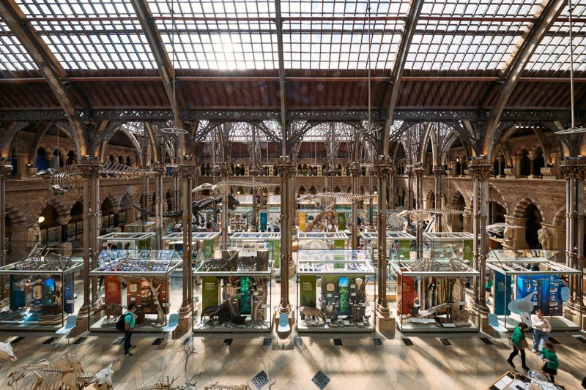
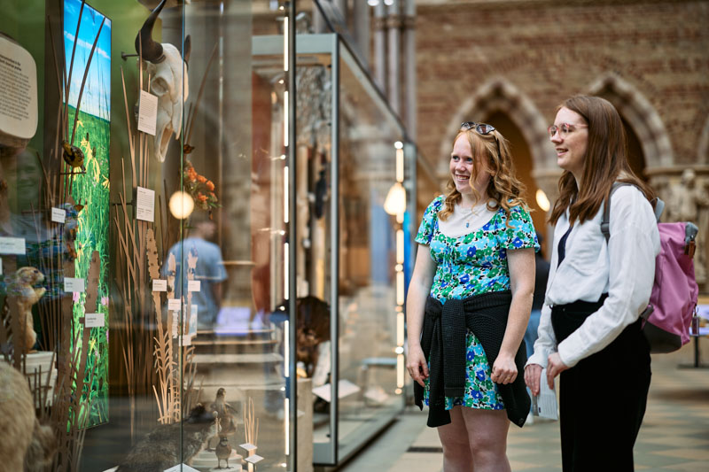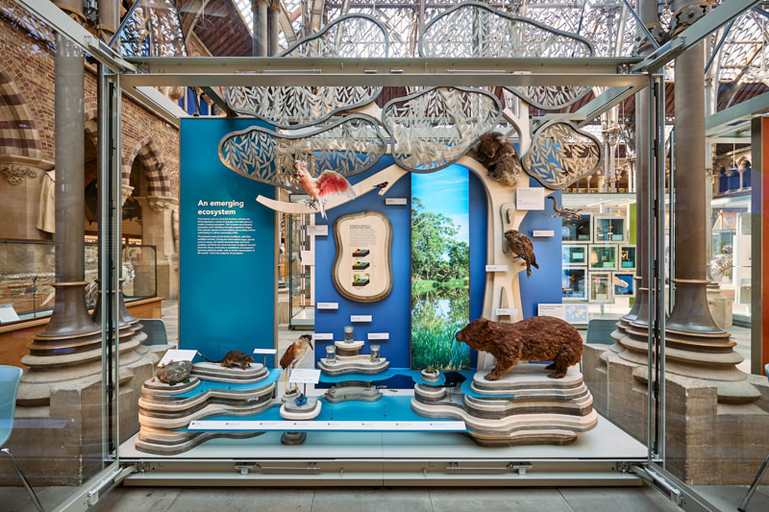
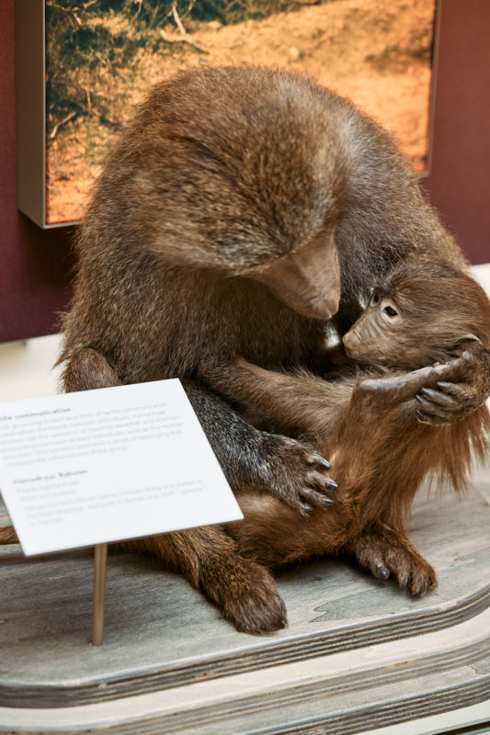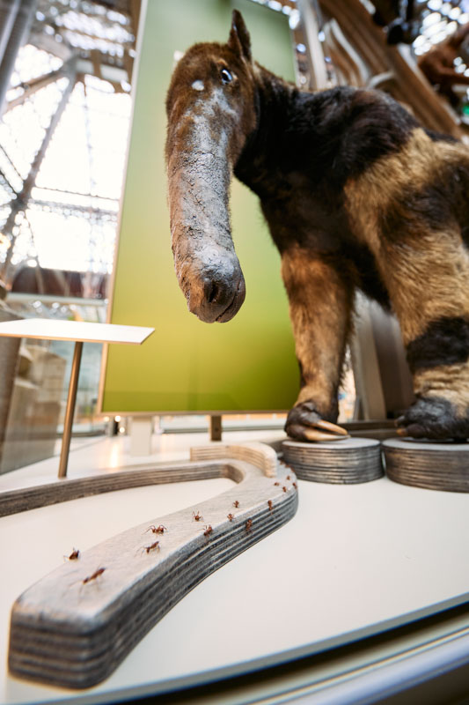
High resolution images are available for use by members of the media here.

For further information:
Scott Billings
Life, As We Know It project manager
Museum of Natual History
scott.billings@oum.ox.ac.uk
01865 270925

Notes to editors
About Oxford University Museum of Natural History

Founded in 1860 as the centre for scientific study at the University of Oxford, the Museum of Natural History now holds the University’s internationally significant collections of entomological, geological and zoological specimens. Housed in a stunning Pre-Raphaelite-inspired example of neo-Gothic architecture, the Museum is free to enter, and its growing collections underpin a broad programme of natural environment research, teaching and public engagement.

www.oumnh.ox.ac.uk
www.morethanadodo.com

About FCC Environment
FCC Environment is the leading UK waste and resource management company and is part of a global group with a strong heritage in providing services for communities and business. Its vision is to be the environmental company of choice, delivering change for a sustainable future. It employs 2,400 people and operates more than 200 facilities across England, Scotland and Wales. FCC Environment donates the landfill tax credits that are generated by its operations to FCC Communities Foundation, in order to add value to the environmental and social infrastructure of the communities around landfill sites.
www.fccenvironment.co.uk
About FCC Communities Foundation
FCC Communities Foundation is a not-for-profit business that awards grants for community, conservation and heritage projects from funds donated by FCC Environment through the Landfill Communities Fund and Scottish Landfill Communities Fund. Since 1998, FCC Communities Foundation has granted over £200m to more than 7,000 projects which benefit people living within 10 miles of a FCC Environment landfill site. For more information please visit www.fcccommunitiesfoundation.org.uk.
About Landfill Communities Fund / Scottish Landfill Communities Fund
The Landfill Communities Fund and Scottish Landfill Communities Fund - any waste that is discarded which cannot be reused, reprocessed or recycled may ultimately be disposed of in a landfill site. To encourage the re-use, recycle and recovery of more value from waste and use more environmentally friendly methods of waste disposal, Landfill Tax is charged on each tonne of waste sent to landfill. Landfill Operators (LOs) are able to redirect a small proportion of landfill tax liability to support a wide range of community and environmental projects in the vicinity of landfill sites through the Landfill Communities Fund (LCF) and Scottish Landfill Communities Fund (SLCF). The LCF is regulated by ENTRUST on behalf of HM Revenue & Customs, and the projects are delivered by enrolled Environmental bodies (EBs). The SLCF is regulated by SEPA on behalf of Revenue Scotland and projects are delivered by Approved Bodies (ABs).

About the DCMS/Wolfson Museums and Galleries Improvement Fund
The DCMS/Wolfson Museums and Galleries Improvement Fund provides capital funding for museums and galleries across England to improve displays, protect collections and make exhibitions more accessible to visitors. In 2022-24, DCMS and the Wolfson Foundation each contributed £2 million to the Fund, which has benefitted more than 400 projects in its 20-year history.

