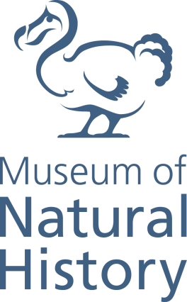

Documentation Assistant

Grade 4: £22,017 - £25,482 p.a. (pro-rata)

Part time (0.5FTE)

Fixed term for 12 months

We are seeking a detail orientated and highly organised team player with good documentation skills to assist with the documentation of the collections at the Oxford University Museum of Natural History in accordance with Museum Accreditation and SPECTRUM documentation standards.

This role will primarily involve working with digital documentation records to improve the quality of object and archive catalogue records by checking their validity, consistency and completeness. Duties will also include working with images and other digital surrogates and related metadata. Overall the post holder will be assisting the Digital Collections Manager with the implementation of the Museum’s newly integrated Collections Management System (KE EMu).

The successful candidate will have first-rate IT skills and experience working with museum or archive documentation. Familiarity with museum documentation standards and collections management systems is essential, with direct experience using KE EMu, desirable.

Applicants are required to complete the online application form on Oxford University’s website and include a CV and supporting statement addressing the selection criteria. The supporting statement must explain how you meet each of the selection criteria for the post using examples of your skills and experience. This may include experience gained in employment, education, or during career breaks (such as time out to care for dependants).
For further details on the Museum please see our website www.oum.ox.ac.uk. Please contact the Head of Print and Digital Collections Kathleen Diston using the contact details below.
Closing date: Monday 12th November 2018
Interview date: Friday 23rd November 2018
Contact: kathleen.diston@oum.ox.ac.uk 01865 272982

